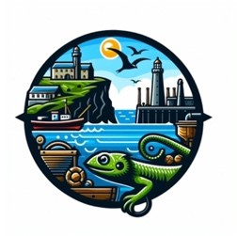
Coverack School
Lizard Schools Curriculum
Subject: Geography

We are committed to providing a curriculum that is underpinned by three essential drivers: aspiration, curiosity, and diversity. We aim to empower our learners to develop the knowledge, skills, and values they need to not only succeed in their education but also to become successful global citizens. Through our rigorously and consciously crafted curriculum, we teach clear sequences of enquiry-based learning encompassing the National Curriculum, reflecting the unique and special part of the world in which we live. We believe in helping our children flourish, realising their full potential, and fostering a caring and nurturing community where every child is valued.

Our Geography Concepts

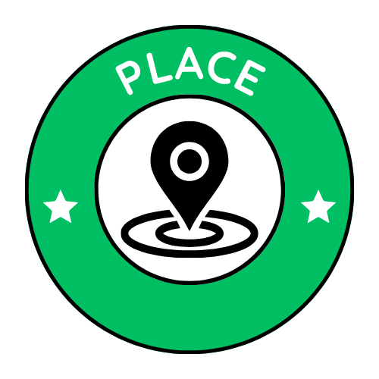
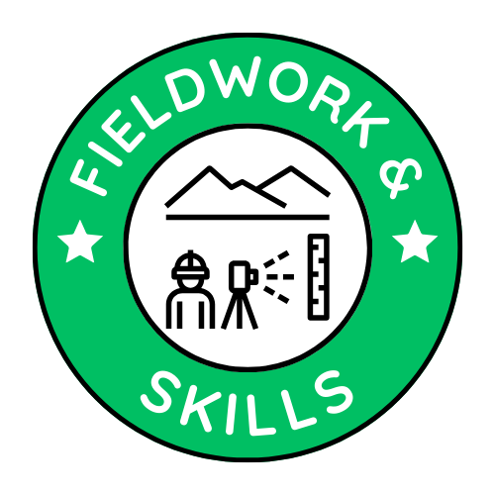
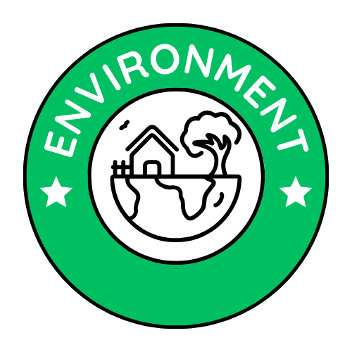
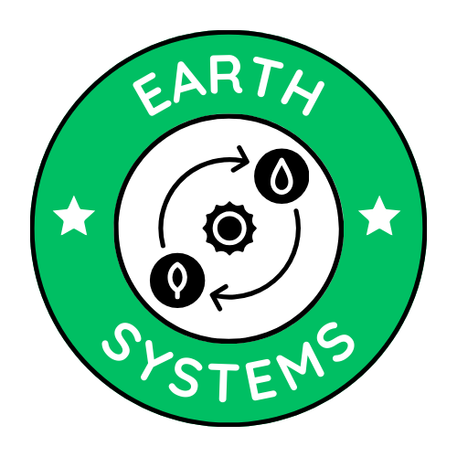

Curriculum Overview
KS1
Key Stage 1 CYCLE 1
AUTUMN | SPRING | SUMMER
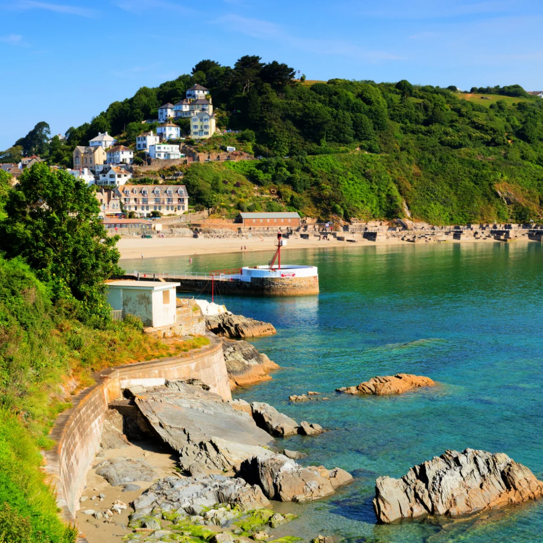  What is the geography of where I live?  1. What is the name of the town / village I live in?  2. Where is my home area on a map of the United Kingdom?  3. What are the key physical and human features of my locality?  4. How do I make a map or plan?  5. How does my local area compare with somewhere else in the country (London)?  6. How can I use aerial photographs and plan perspectives to recognise features? | 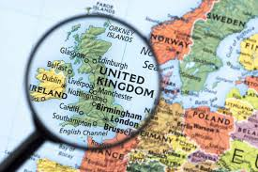1,500 × 1,002  What makes up the UK?  1. What does the world look like and where is the UK?  2. What is an atlas and how do I use it?  3. Why is London important?  4. What are the key features of England and Wales?  5. What are the key features of Scotland and Northern Ireland?  6. What makes up the UK? | 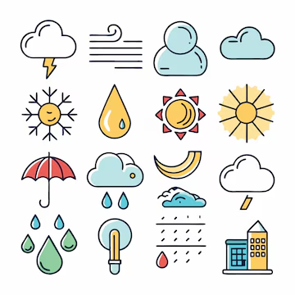  How does weather affect our lives?  (hot and cold places)  1.What is the difference between weather and climate?  2.How can we read a weather map?  3.How can we collect weather data?  4.How can collect and record weather data?  5.How can we present weather data?  6.How can we analyse our weather data and evaluate our field work?
Key Stage 1 CYCLE 2
AUTUMN | SPRING | SUMMER
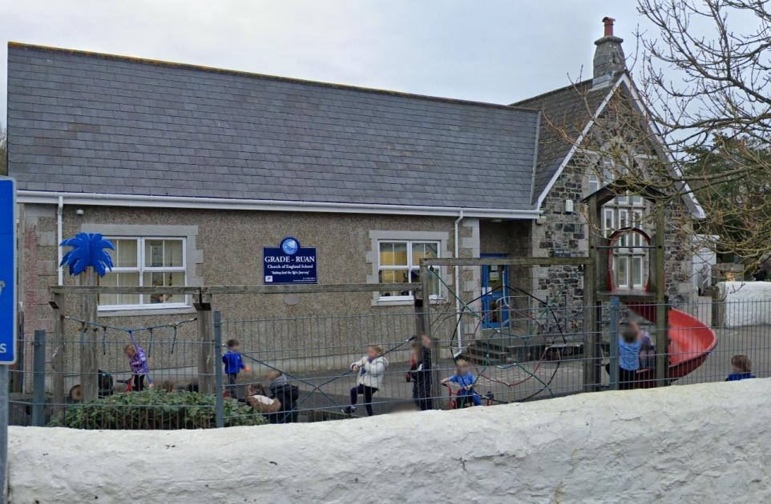  Why is there a school in our village?  1. What is in our classroom?  2. What is our school made up of?  3. Where is our school? (Local walk around the village)  4. What is in our village?  5. Where is my village in the country?  6. Why is there a school in our village? | 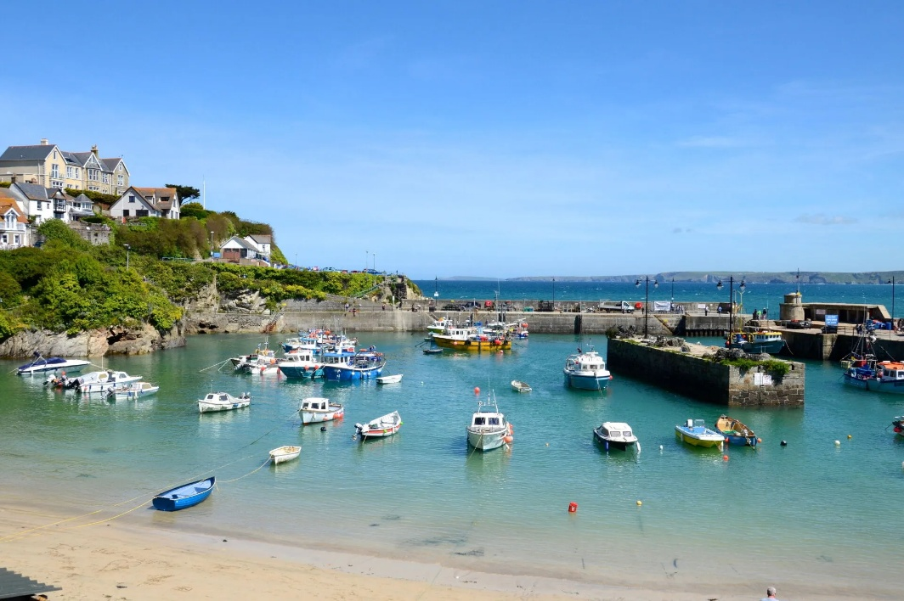  How are we connected to the sea?  1. How can we get to the sea?  2. Are all the seas surrounding the UK the same?  3. What is the difference between the ocean and the sea?  4.What are the different oceans and where are they?  5Why does the sea matter to us?  6. How are we connected to the sea? | 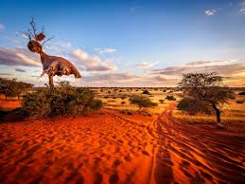  How does the Kalahari Desert compare with where I live?  What are continents and oceans?  What are deserts and where in the world can they be found?  What is the weather and climate like in deserts?  Are all deserts the same?  Who uses or lives in deserts and how do they do this?  How are deserts similar or different to where we live?  How does the Kalahari Desert compare with where I live?

Curriculum Overview
KS2
Key Stage 2 CYCLE 1
AUTUMN | SPRING | SUMMER
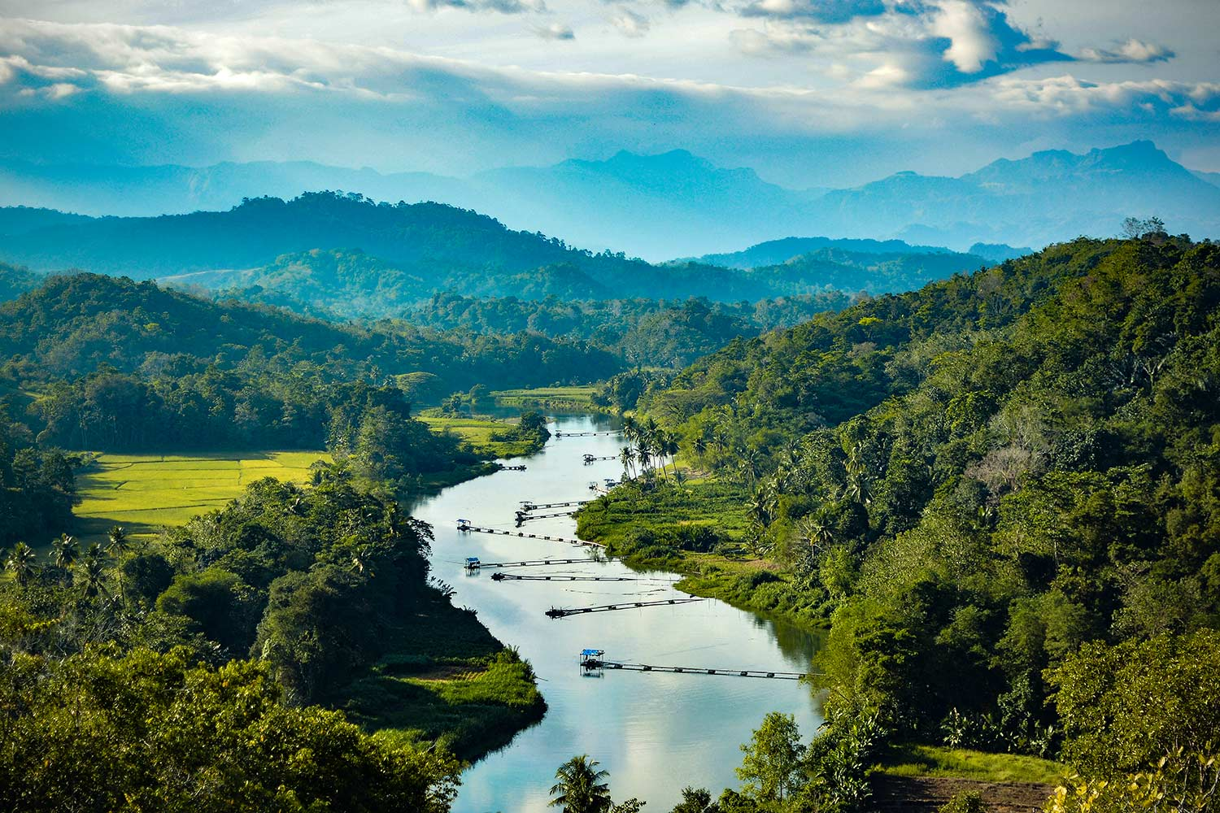  What is a river and what does it do?  1.What are the features of a river?  2.What land does a river create?  3. Where does a river go?  4.Why does a river flood?  5. What impact does a flood do?  6. Where are the major rivers in the UK and World? | 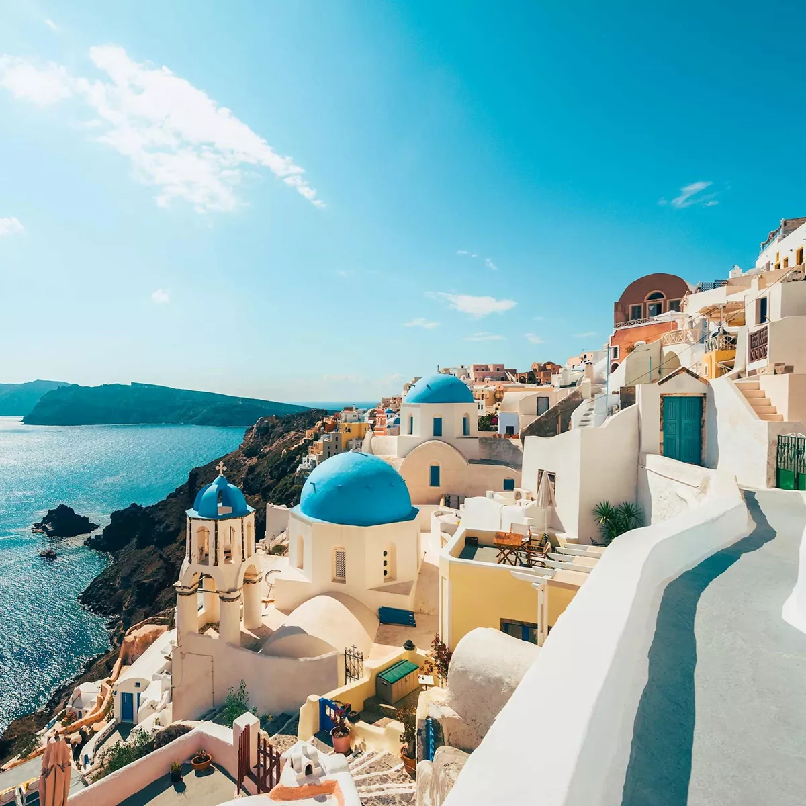  What would it be like to live in Greece compared to Cornwall?  - What foods are grown locally in Greece and why compared to Cornwall?  - What kind of animals are common in Greece compared to Cornwall?  - What is the climate like in Greece compared to Cornwall?  - What human and physical features would you find in Greece?  - What human and physical features would you find in Greece?  What does Greece have to offer? Would you live there or in Cornwall? | What is life like in a desert?  1.What is a desert and where are they located?  2 What is the climate like in a hot desert? – Mojave desert case study  3How do animals and plants adapt to a hot desert?  4 What is the climate like in a cold desert? – Patagonia desert case study  5 what challenges face the worlds deserts?  6 How does life in a hot desert compare to a cold desert?

Key Stage 2 CYCLE 2
AUTUMN | SPRING | SUMMER
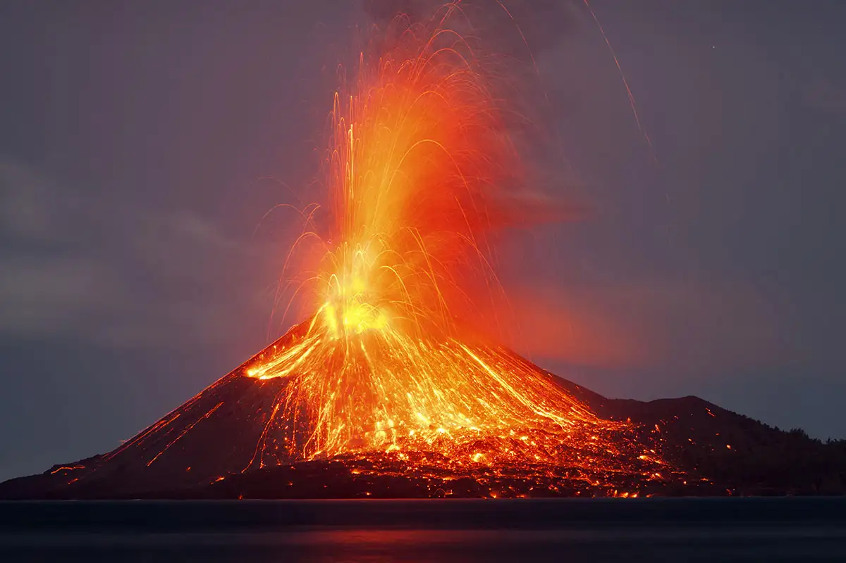  How can tectonics affect us?  - What is under our feet?  - How is a mountain formed?  - How are volcanoes formed?  - Would you live near a volcano?  - Why do earthquakes happen?  - Would you live on a fault line?  - How does a tsunami happen? | 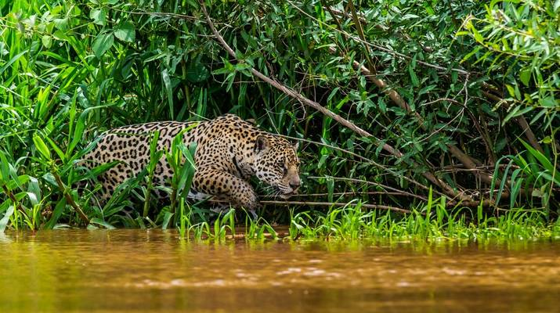  Why should we protect the Amazon rainforest?  - What is a rainforest  - Where is the Amazon rainforest?  - What are the key features of the Amazon rainforest?  - How do people live in the Amazon rainforest?  - Does the Amazon rainforest produce food?  - What does the future look like for the Amazon rainforest? | 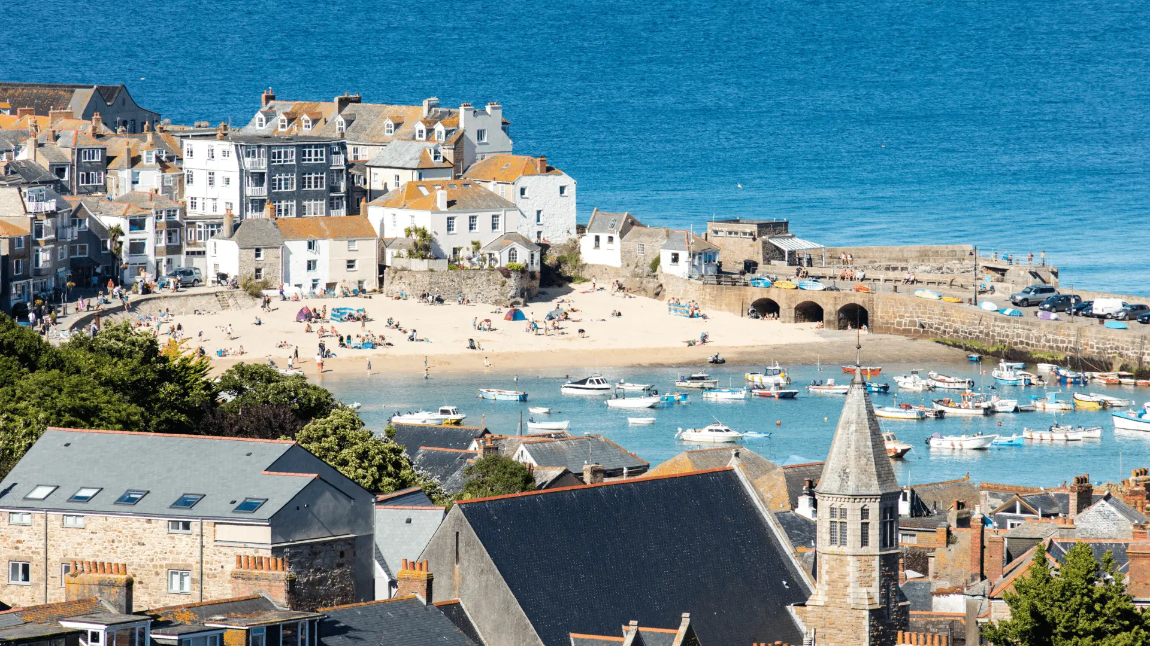  Why do people visit St Ives?  - What type of settlement is it?  - Why does a settlement change?  - How has St Ives Changed?  - How can I find out why people visit St Ives?  - Fieldwork  - Why do people visit St Ives?

Key Stage 2 CYCLE 3
AUTUMN | SPRING | SUMMER
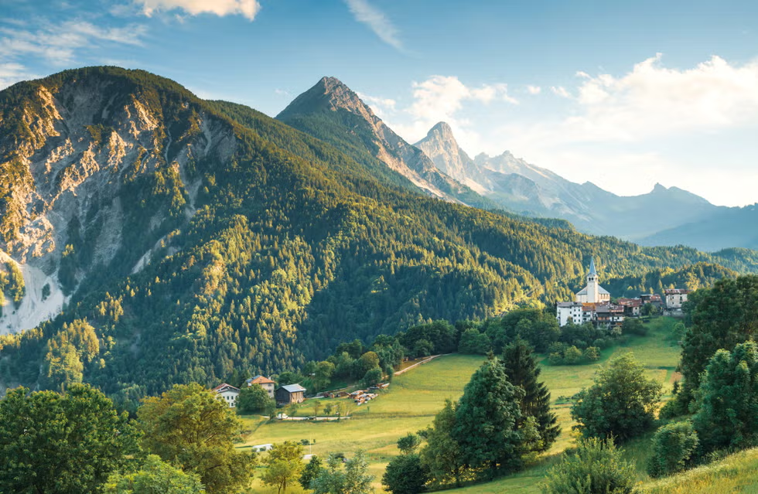  Why are mountains important to the Earth and the people who live near them?  1.What makes a mountain different from a hill?  2. How are mountains made?  3. What mountains can we find in the UK?  4. Why is life on a mountain so unique?  5. How do people live and work in mountain areas?  6. Why is it important to protect mountains and the life they support? | 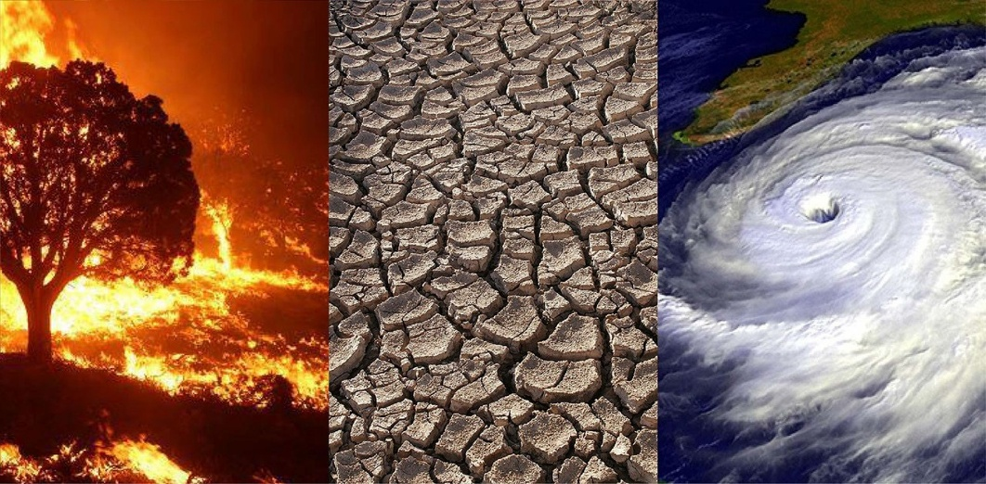  How is climate change affecting the world?  1.Climate or weather?  2. What is climate change?  3. How has climate change impacted the world so far?  4.Can climate change be stopped?  5.How is climate change affecting the world? |   How is our coast changing?  1.What is the coast of the UK?  2. What is coastal erosion?  3. How is erosion affecting us?  4. How does erosion affect habitats and wildlife?  5. Can erosion be stopped?  6.How is our coast changing?

Key Stage 2 CYCLE 4
AUTUMN | SPRING | SUMMER
  Why is Fairtrade fair?  1.What is trade?  2.How did trade get global?  3.What is Fairtrade?  4. How does Fairtrade help the people involved?  5. What fair trade for?  6. Why is Fairrtrade Fair | 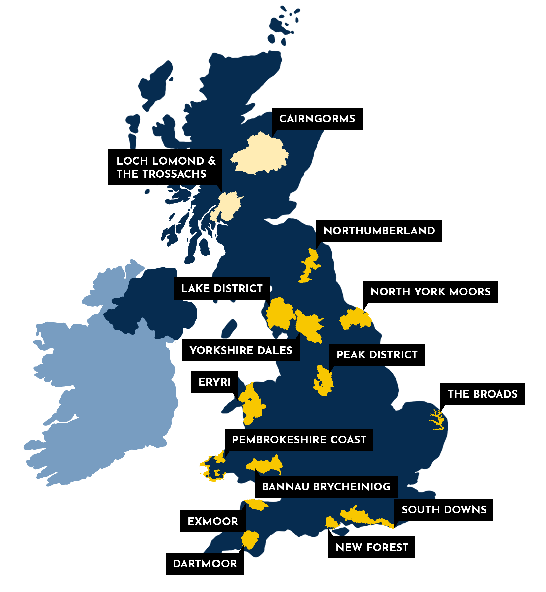  Who are Britain’s National Parks for?  1.What is a National Park and why do they exist?  2. Where are our National Parks?  3. What and where is Dartmoor?  4. What and where is the Lake District?  5.What and where is Eyri (Snowdonia)?  6. Who are Britain’s National Parks for? | 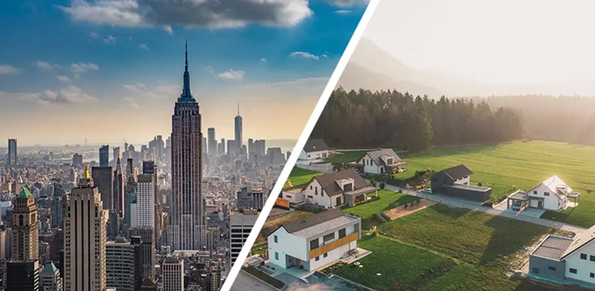  How are settlements different? (rural v urban)  1.What are the key characteristics of Cornwall and Bristol?  2.How does the physical geography of Cornwall and Bristol shape life in each location?  3.How does population density and settlement pattern differ between Cornwall and Bristol?  4.How do the economies of Cornwall and Bristol differ?  5.How does culture and lifestyle differ between Cornwall and the city?  6.How are Cornwall and Bristol planning for a sustainable future?

KS1 Skills  Coverage | Cycle 1  Autumn | Cycle 1  Spring | Cycle 1  Summer | Cycle 2  Autumn | Cycle 2  Spring | Cycle 2  Summer
 |  |  | 

KS2 Skills  Coverage | Cycle 1  Autumn | Cycle 1  Spring | Cycle 1  Summer | Cycle 2  Autumn | Cycle 2  Spring | Cycle 2  Summer | Cycle 3  Autumn | Cycle 3  Spring | Cycle 3  Summer | Cycle 4  Autumn | Cycle 4  Spring | Cycle 4  Summer

