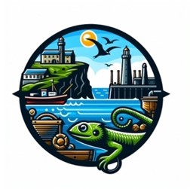
Coverack School
Lizard Schools Curriculum
Subject: History

We are committed to providing a curriculum that is underpinned by three essential drivers: aspiration, curiosity, and diversity. We aim to empower our learners to develop the knowledge, skills, and values they need to not only succeed in their education but also to become successful global citizens. Through our rigorously and consciously crafted curriculum, we teach clear sequences of enquiry-based learning encompassing the National Curriculum, reflecting the unique and special part of the world in which we live. We believe in helping our children flourish, realising their full potential, and fostering a caring and nurturing community where every child is valued.

Our History Concepts

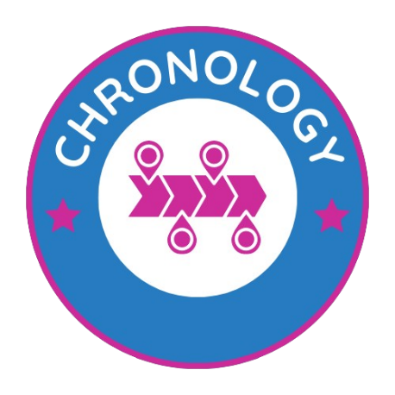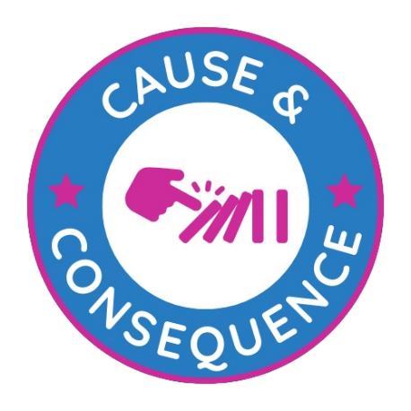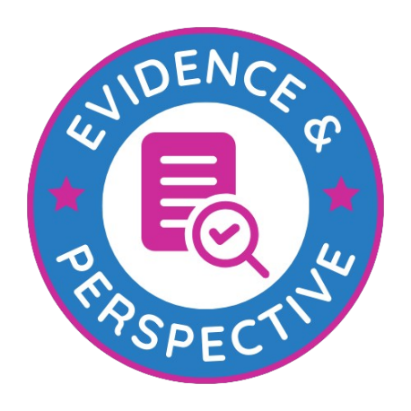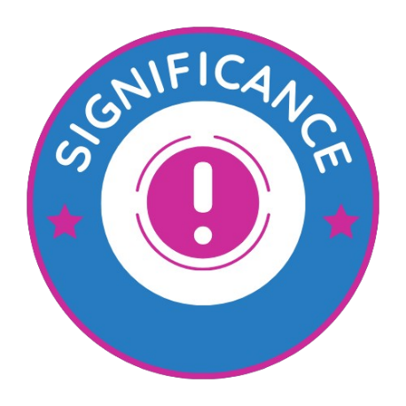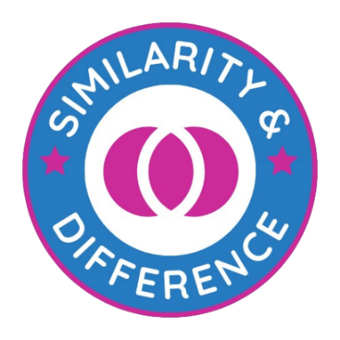

Curriculum Overview
KS1
Key Stage 1 CYCLE 1
AUTUMN | SPRING | SUMMER
  How do we know that toys changed since our grandparents were young?  Step 1: How can we find out about the past?  Step 2: What are our toys like now?  Step 3: What was my favourite toy when I was a baby?  Step 4: What were our parents’ toys like? How do we know?  Step 5: What were our older relative’s toys like? How do we know?  Step 6: How have toys changed since our older relatives? | 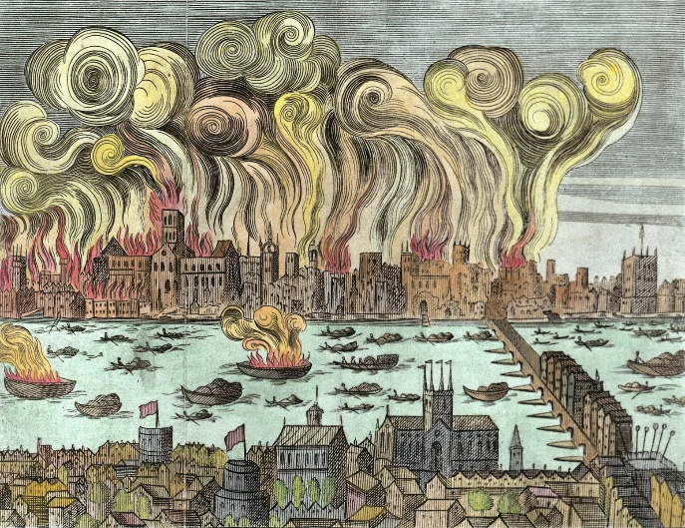  Who was to blame and who helped in the Great Fire of London?  Step 1: What was London like in 1666?  Step 2: What happened on 2nd September 1666?  Step 3: How did the fire spread?  Step 4: What was left of London?  Step 5: How was London rebuilt?  Step 6: How did the fire impact the future? | 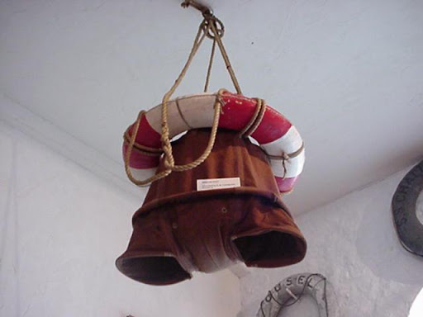  What impact has Henry Trengrouse had on life today?  Step 1: Who was Henry Trengrouse?  Step 2: When was Henry Trengrouse alive?  Step 3: What did Henry Trengrouse do?  Step 4: What was Henry Trengrouse’s invention?  Step 5: What was the impact locally and nationally of the invention?  Step 6: What impact does Henry Trengrouse have on life today?

Key Stage 1 CYCLE 2
AUTUMN | SPRING | SUMMER
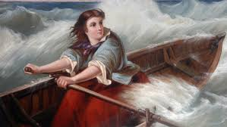  Was Grace Darling heroic?  Step 1: What did Grace do that made her famous and why is she remembered today?  Step 2: What did Grace do what she did?  Step 3: Are all versions of Grace’s story the same?  Step 4: How do we know about Grace’s actions which happened so long ago?  Step 5: How did sea rescue improve after her heroice act?  Step 6: How should we remember Grace Darling 170 years after she died? | 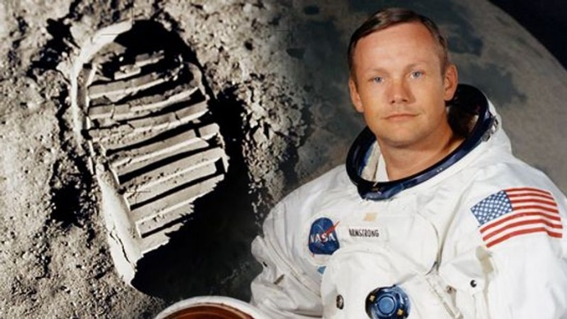  How have explorers changed our view of the world?  Step 1: How can we find out about the past?  Step 2: Why do people explore?  Step 3: Who are the important explorers from the past?  Step 4: What are the famous explorations of the past?  Step 5: Can we compare different explorations?  Step 6: How have explorations changed over time? | 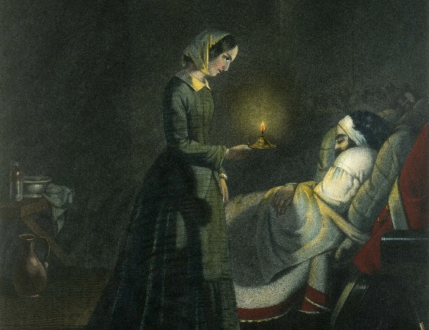  What impact did these significant women have?  Step 1: How can we work out why Florence Nightingale is famous?  Step 2: What were the most important moments in Florence Nightingale’s life?  Step 3: How important was Florence Nightingale’s life?  Step 4: How did life change for Florence Nightingale after the Crimean War?  Step 5: What made Florence Nightingale so special?  Step 6: How is Florence Nightingale remembered today?

Curriculum Overview
KS2
Key Stage 2 CYCLE 1
AUTUMN | SPRING | SUMMER
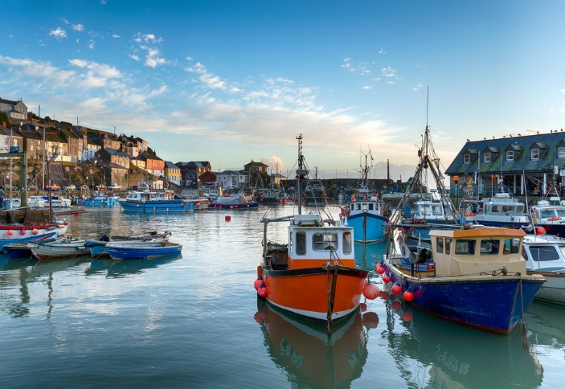  How has fishing changed in Cornwall?  Step 1: How did people fish before 1600s?  Step 2: What impact did Seine and Drift have on fishing?  Step 3: How did fishing grow into a lucrative industry?  Step 4: How did motorisation change fishing?  Step 5: How have modern fishing methods impacted Cornwall? | 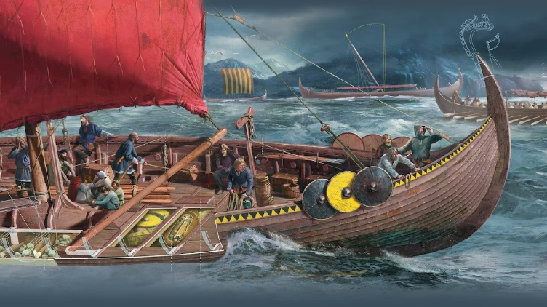  Why did the Vikings raid Britain?  Step 1: What were the Vikings like and where were the Vikings from?  Step 2: What push and pull factors led the Vikings to Britain?  Step 3: Were the Vikings settlers or invaders?  Step 4: How did the Vikings try to take over the country?  Step 5: How close did they get to taking over the country?  Step 6: Have recent excavations changed our view of the Vikings? | 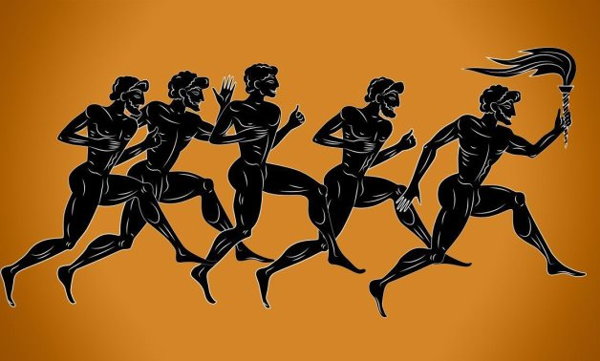  Why did the Olympics originate in Greece?  Step 1: How can we know so much about the Ancient Greeks who lived 2,500 years ago?  Step 2: What was everyday life like in Athen?  Step 3: How did democracy in Ancient Greece influence the Olympic Games?  Step 4: How did the Greeks make the games significant and inclusive?  Step 5: How did the value of the games reflect the value of Greek society?  Step 6: What differences are there between a modern Olympic Games and Ancient Olympic Games?

Key Stage 2 CYCLE 2
AUTUMN | SPRING | SUMMER
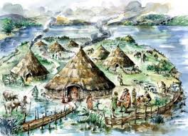  How did settlements change from the Stone Age to the Iron Age?  Step 1: What was it like in the palaeolithic and Mesolithic eras?  Step 2: What changed from the Palaeolithic to the Mesolithic?  Step 3: What key changes took place during the Neolithic?  Step 4: How did daily life change from the Stone Age to the Iron Age?  Step 5: What was life like in the South West during the Stone Age?  Step 6: Why did settlements change from the Stone Age to the Iron Age? | 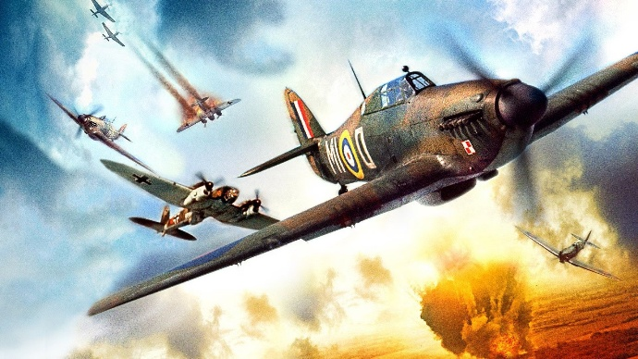  Why was the Battle of Britain a turning point in WW2?  Step 1: What significant events led to the Battle of Britain?  Step 2: Was Britain prepared for invasion?  Step 3: To what extent did the Nazis succeed or fail?  Step 4: Would your rather fly a Messerschmitt or a Spitfire?  Step 5: Did woment play a part in the Battle of Britain?  Step 6: How important a victory was the Battle of Britain? | 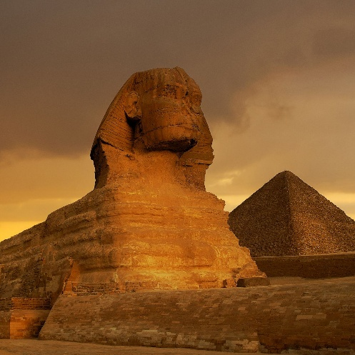  What made the Ancient Egyptian civilisation significant?  Step 1: So you think you know about Ancient Egypt?  Step 2: How can we discover what Ancient Egypt was like over 5,000 years ago?  Step 3: Who built the pyramids?  Step 4: What can an old clay model tell us about Ancient Egypt 5,000 years ago?  Step 5: How were the dead treated in Ancient Egypt?  Step 6: What did Ancient Egypt have in common with other civilisations of the time?

Key Stage 2 CYCLE 3
AUTUMN | SPRING | SUMMER
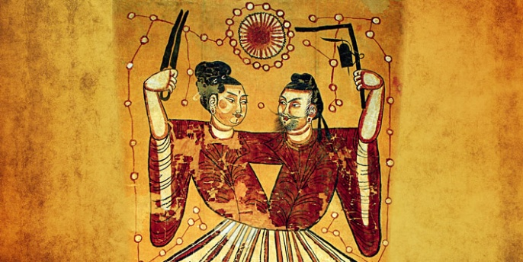  Why was the Shang civilisation so successful?  Step 1: Why do you think the Shang Dynasty might be important?  Step 2: How different was Shang society to other civilisations of the time?  Step 3: What can we tell about the Shang Dynasty from the objects that have survived?  Step 4: Why has our understanding of the Shang Dynasty changed so much in the last 100 years?  Step 5: What was distinctive about the Shang people’s beliefs?  Step 6: If the Shang Dynasty was so well organised why did it come to an end after 600 years? | 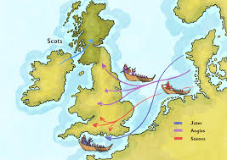  Why did the Anglo-Saxons and Scots settle in Britain?  Step 1: Why did the Anglo-Saxons invade?  Step 2: Where did the early Anglo-Saxons live and how do we know?  Step 3: Who were the Scots and why did they want to settle?  Step 4: Who was the owner of the mystery ship burial at Sutton Hoo?  Step 5: How did people’s lives change when Christianity came to Britain? | 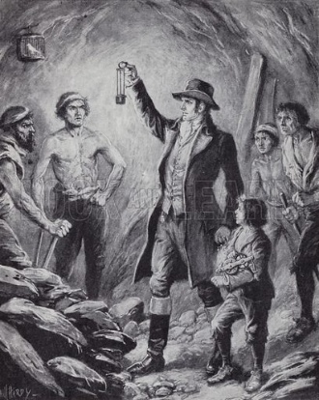  Who were the significant people in Cornish mining?  Step 1: Why was Cornwall so important in the mining industry?  Step 2: Who was Richard Trevithick?  Step 3: Who was Humphrey Davy?  Step 4: Who were the Bassett Family?  Step 5: Who was William Bickford Smith?  Step 6: How did these significant Cornish people make a global impact?

Key Stage 2 CYCLE 4
AUTUMN | SPRING | SUMMER
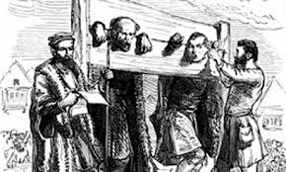  How has crime and punishment changed from the Anglo-Saxons to the present day?  Step 1: How were criminals punished 800 years ago and how do we know?  Step 2: How did crime and punishment change between 1500 and 1750?  Step 3: Why did punishments become so bloody in the 18th century?  Step 4: Why did so much change happen in crime and punishment in the 19th century?  Step 5: Has the way we catch and punish criminals improved in the last 100 years?  Step 6: How has crime and punishment changed from the Anglo-Saxons to the present day? | 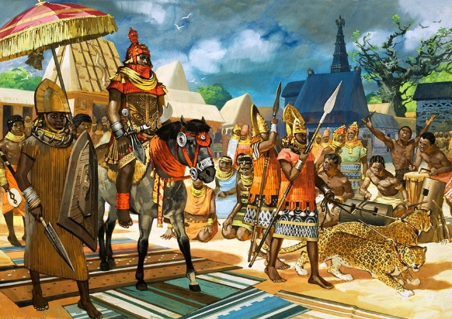  How did the British impact the Benin civilisation?  Step 1: Why do you think we should study Benin?  Step 2: What sort of place was Benin 500-1000 years ago?  Step 3: What can we tell about Benin society from the images and artefacts that have survived?  Step 4: What changes took place when the European settlers started trading?  Step 5: Why did the Victorians get involved in Benin and what were the effects on the Benin people?  Step 6: Should the Benin bronzes be returned? | 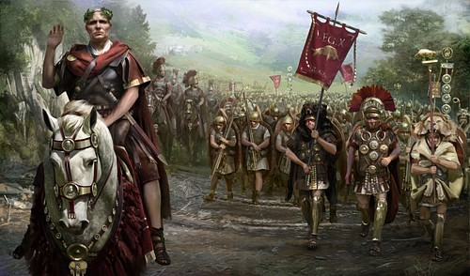  How did the Romans impact Britain?  Step 1: Why did the Romans invade Britain?  Step 2: Should the Celts take on the Romans?  Step 3: Why did the Romans build roads?  Step 4: What were Roman towns and cities like?  Step 5: How did the Romans keep their towns and cities clean?  Step 6: Can we still see the influence of the Romans on life today?

KS1 Skills  Coverage | Cycle 1  Autumn | Cycle 1  Spring | Cycle 1  Summer | Cycle 2  Autumn | Cycle 2  Spring | Cycle 2  Summer
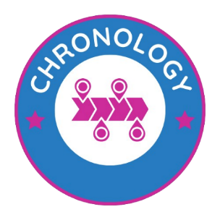
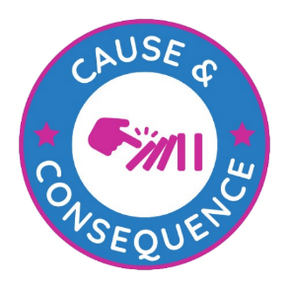 |  | 
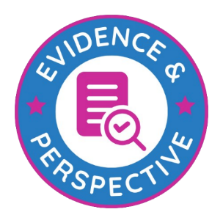
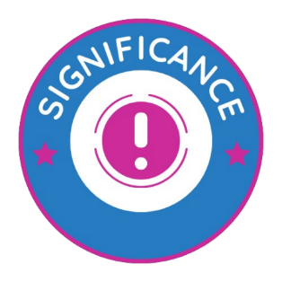 |  |  |  |  |  | 
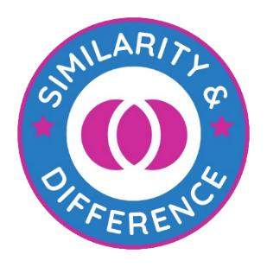

KS2 Skills  Coverage | Cycle 1  Autumn | Cycle 1  Spring | Cycle 1  Summer | Cycle 2  Autumn | Cycle 2  Spring | Cycle 2  Summer | Cycle 3  Autumn | Cycle 3  Spring | Cycle 3 Summer | Cycle 4  Autumn | Cycle 4  Spring | Cycle 4  Summer
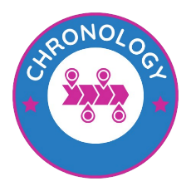
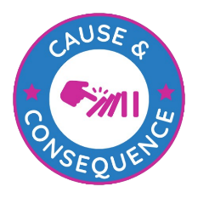 | 
